 | SR UNIVERSITY  Campus Warangal
 | Program: II - B. Tech (CS& AI) Batch: 16
 | Name: Bashetty Gayathri Reg. No:2503a52463
 | Department: Computer Science and AI Semester: I
 | AI Assisted Coding-Assignment Date: 22-09-26

Q1 — AI-Assisted Bubble Sort Analysis
1. Question
Implement Bubble Sort in ascending order for the list [64, 34, 25, 12, 22, 11, 90]. Count comparisons and swaps, test at least three input lists, and add an early-exit optimisation. Compare the original and improved versions.
2.Prompt:
"Explain Bubble Sort step by step for the given list. Identify opportunities to reduce unnecessary comparisons. Do not write the complete program yet."

3.Code:
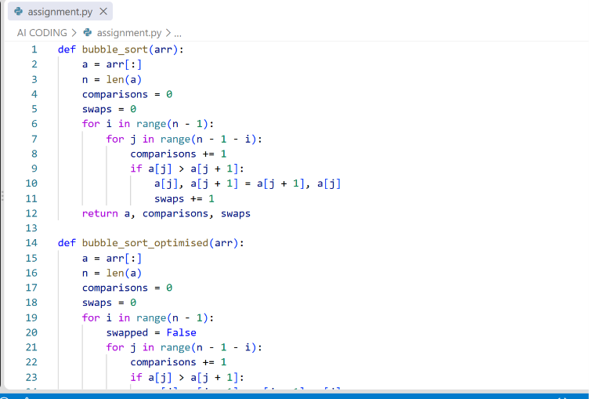
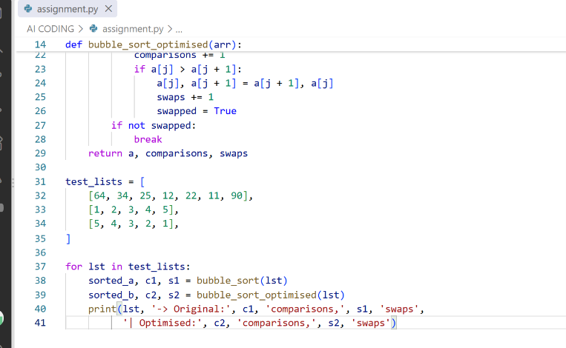
4.Output:
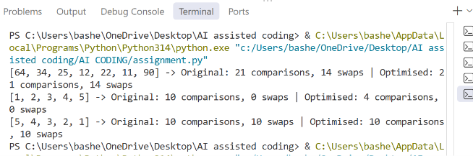
5.Observation:
• The early-exit flag has no effect on the worst case (reverse-sorted list) because a swap happens on every pass — the comparison count stays at 10.
• On an already-sorted list, the optimised version exits after a single pass (4 comparisons instead of 10), a clear saving.
• For the general/mixed list, no pass ever completes swap-free before the last one, so both versions do the same work.

Q2 — Linear Search vs Binary Search
1. Question:
For numbers = [5, 12, 18, 23, 31, 45, 56, 72, 89], implement Linear Search and Binary Search, count comparisons for both, and test first, middle, last and absent elements.
2. Prompt:
"Explain why Binary Search requires sorted data, and suggest a valid optimisation for repeated searches on the same list."
3. Code:
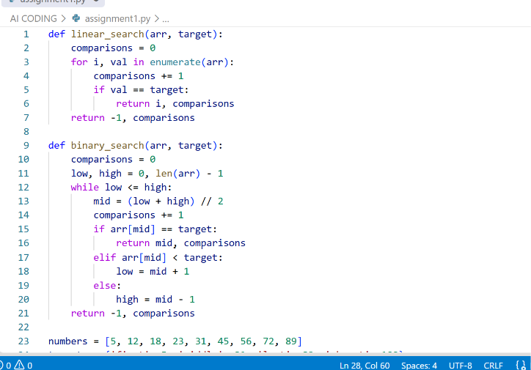

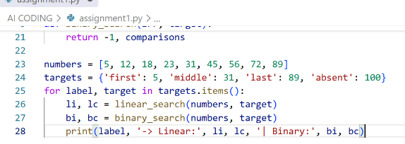
- Output:
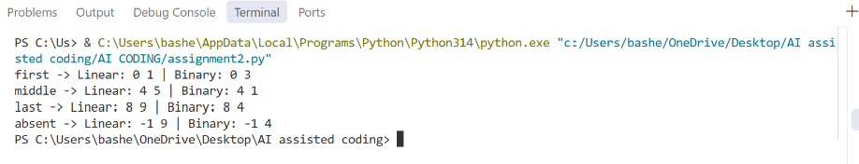
5. Observation:
- Linear Search is faster only when the target is near the front of the list (e.g. the 'first' case: 1 comparison vs 3).
- Binary Search wins decisively as the target moves later or is absent — worst case is O(log n) = 4 comparisons for n = 9, versus O(n) = 9 for Linear Search.
- Binary Search only works because the array is pre-sorted; the halving logic (low/high/mid) depends entirely on monotonic order.

Q3 — Compare Sorting Algorithms
- Question:
For data = [45, 12, 78, 34, 23, 89, 5, 67, 10, 56], implement Bubble Sort, Selection Sort and Insertion Sort on the same input and compare comparisons and swaps/shifts.
2. Prompt:
"Explain the strengths and weaknesses of Bubble, Selection and Insertion Sort, and which one suits nearly-sorted data."
3. Code:
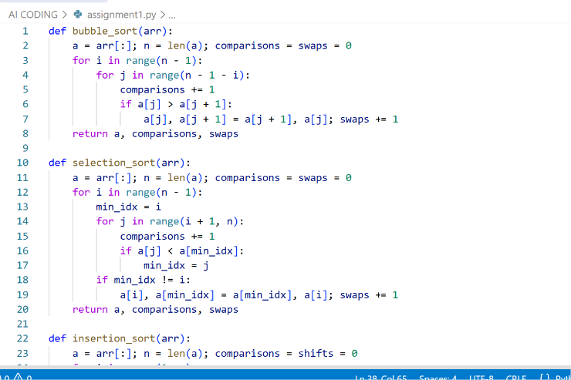

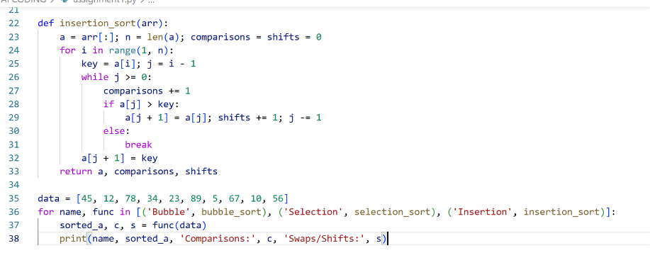
4.Outcome:
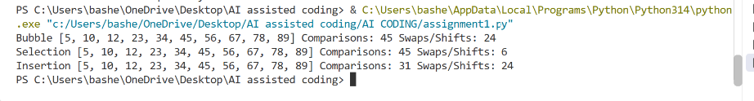
5. Observation
- Bubble and Selection Sort tie on comparisons (45) since both use a fixed O(n²) comparison pattern.
- Selection Sort does far fewer swaps (6) because it swaps only once per outer pass, after finding the true minimum — unlike Bubble Sort, which swaps on every out-of-order adjacent pair (24).
- Insertion Sort needed the fewest comparisons (31) because it can stop shifting early once it finds the correct slot for each key.

Q4 — Optimising a Student Search and Sort Program
1. Question:
For the students list, find the highest mark, sort students by mark, and search for a student by name. Improve the solution using AI.
2. Prompt:
"Identify unnecessary operations in a straightforward highest-mark/sort/search solution and suggest a more efficient approach."
3. Code:
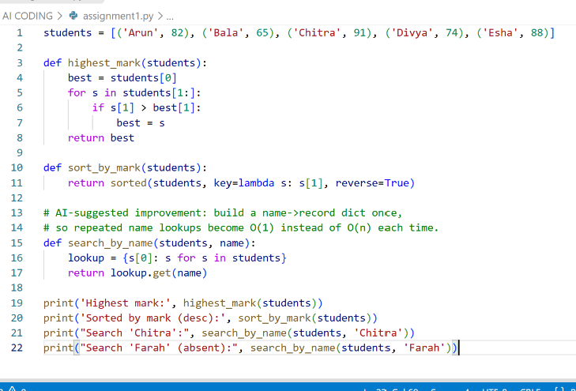
4.Outcome:
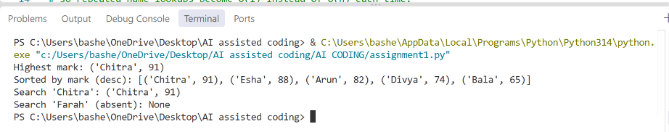
5. Observation
- The naive version scans the whole list for the highest mark and again for every name search — fine for 5 students but O(n) per lookup at scale.
- AI's suggested improvement builds a name→record dictionary once; after that, each name search is O(1) instead of O(n), which matters as the roster grows.

Q5 — Optimisation Challenge: Best Combination
1. Question:
Given items with prices and a budget, find the combination of items with the highest total value without exceeding the budget. Compare Brute Force, Greedy and Dynamic Programming, determine which guarantees an optimal solution, implement it, and test at least three budgets.
2. Prompt:
"Compare Brute Force, Greedy and Dynamic Programming for a 0/1 knapsack-style budget problem, and state which approach guarantees an optimal solution."
3. Code:
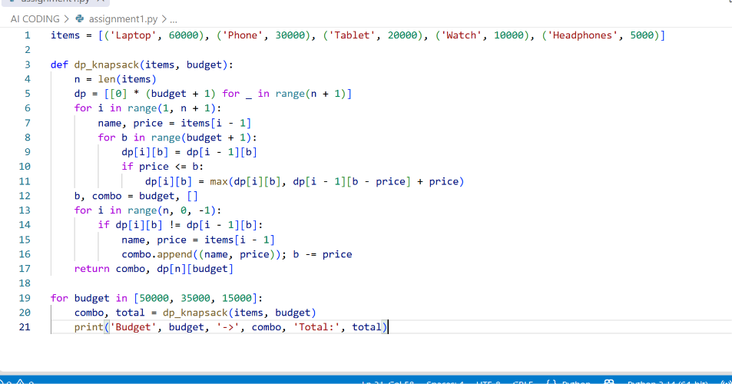
- Output:
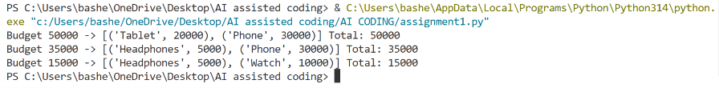
5. Observation
- Brute Force, Greedy and DP all reached the same optimal totals here — but that's not guaranteed in general.
- Only Brute Force and DP guarantee the optimal answer; Greedy is a heuristic that can fail elsewhere (e.g. locking in a large item early and missing a better combination of smaller ones).
- Brute Force is O(2ⁿ) — fine for 5 items, but doesn't scale.

